MOLE RELATIONSHIPS IN A CHEMICAL REACTION

Objective:

Cu(s) + AgNO3(aq) →

To determine the products of the above reaction. Assume copper forms a +2 ion in a compound.

Materials: Copper wire (16 gauge), balance, 50-mL beaker, AgNO3 (0.20-M), wash bottle,

stirring rod, filter paper, distilled water

Procedure Day 1:

1.Obtain a copper wire about 3 inches long. Form the wire into an elongated coil and bend it to form a hook at the opposite end. Find the mass of the copper wire and record. Use the same balance throughout this lab.

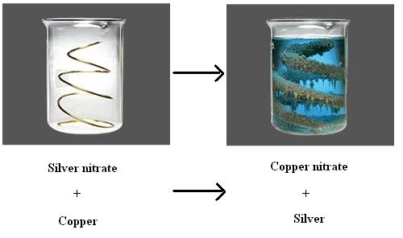

Coil without hook. Make a hook.

2. Using a graduated cylinder, add about 25 mL of 0.20-M AgNO3 solution into a 50-ml beaker. Record the exact volume.

(Silver nitrate solution will stain your skin--BE CAREFUL!!!)

3. Suspend the coil of copper in the solution by hanging the hook over the side of the beaker. Let the beaker stand overnight.

Procedure Day 2:

4. Carefully shake the silver from the copper coil into the beaker. Rinse the coil with water and allow it to dry. Find its mass and record.

5. Find the mass of a piece of filter paper and record. Write your group number in pencil on the filter paper. Filter the supernate (you know the liquid stuff) to recover the silver. Rinse the beaker and the filter paper with distilled water. Take the filter paper out of the funnel and spread out on paper towel to dry overnight.

Procedure Day 3:

6. Find the mass of the silver.

7. Using the mass of copper **reacted**, calculate the mass of silver produced theoretically. Find percent yield.

Data:

|  |
| --- |
|  |
| Mass of Copper Wire Before Reaction |  |
| Mass of Copper Wire After Reaction |  |
| Mass of Copper Reacted |  |
| Moles of Copper Reacted |  |
| Volume of AgNO3 added |  |
| Moles of AgNO3 |  |
| Mass of Filter Paper |  |
| Mass of Filter Paper + Silver |  |
| Mass of Silver |  |
| Theoretical Yield of Silver |  |
| % Yield |  |

Calculations:

Find the number of moles of AgNO3  before the reaction.

Find the number of moles of copper before the reaction.

Find the number of moles of copper consumed during the reaction.

Determine the limiting reactant.

Find the theoretical yield of silver.

Find the number of moles of silver produced.

Find the theoretical yield of silver.

Calculate the percent yield of silver

What is the mole ratio of Copper : Silver

Write a balanced equation for the reaction using the mole ratio derived above as the coefficients.

Discussion Questions:

1. During the middle ages, a group of people called alchemists searched unsuccessfully for a way to "transmute" or change one element to another, e.g. lead to gold. Was the copper "transmuted" into silver in this experiment? Explain.

2. How could you determine which reactant was limiting without doing a calculation?

3. Find the number of atoms of copper removed from the wire.

4. How would the calculated mole ratio be affected if the silver were not completely dry when weighed?

Conclusion- Write one. Don’t forget to complete the reaction in the objective.